AICT project
  - AICT


Team Members
- Sana Ali BS-25-IB-110405
- Amber Kamran BS-25-IB-110434

  - Pakistan Institute Of Engineering And Applied Sciences

CAR MAINTENANCE PROJECT

Introduction
The Car Maintenance Application is a simple console-based Python program developed to help car owners keep track of basic maintenance activities. The application allows users to store important car details such as car name, model, current mileage, and previous service information. Instead of remembering service dates manually, the user can use this system to check when maintenance is required.
The main purpose of this project is to make car maintenance tracking easy and organized. It also helps in understanding how real-life problems can be solved using basic programming concepts. This project is developed using simple Python syntax and is suitable for beginners studying Programming Fundamentals.

Project Functionality:
This Car Maintenance Application provides the following functionalities:
Add Car Information
The user can enter car details such as name, model, current mileage, last oil change, tire change, and brake service mileage. This information is stored for future use.
View Car Records
The user can view all saved car records in a readable format, making it easy to check stored information.
Update Oil Change Record
After changing the oil, the user can update the oil change mileage of a selected car.
Check Maintenance Status
The system checks whether oil change, tire change, or brake service is required based on mileage difference and displays appropriate messages.
Service Summary
This feature shows how many cars currently require an oil change, helping the user quickly identify service needs.
Reset Maintenance After Service
Once maintenance is completed, the user can reset service records so the system starts tracking from the current mileage again.
Delete Car Record
The user can remove any car record that is no longer needed.
File Handling
All car records are saved in a text file so that the data is not lost when the program is closed. The data is automatically loaded when the program runs again.

Code:
cars = []
def load_from_file():
try:
file = open("cars.txt", "r")
for line in file:
data = line.strip().split(",")
car = {
"name": data[0],
"model": data[1],
"mileage": int(data[2]),
"last_oil": int(data[3]),
"last_tire": int(data[4]),
"last_brake": int(data[5])
}
cars.append(car)
file.close()
print("Data loaded from file.")
except:
print("No previous data found.")

def save_to_file():
file = open("cars.txt", "w")
for c in cars:
file.write(
c["name"] + "," +
c["model"] + "," +
str(c["mileage"]) + "," +
str(c["last_oil"]) + "," +
str(c["last_tire"]) + "," +
str(c["last_brake"]) + "\n"
)
file.close()
print("Data saved to file.")

def add_car():
print("\n--- Add Car Information ---")
name = input("Enter car name: ")
model = input("Enter car model: ")
mileage = int(input("Enter current mileage: "))
last_oil = int(input("Enter last oil change mileage: "))
last_tire = int(input("Enter last tire change mileage: "))
last_brake = int(input("Enter last brake service mileage: "))

car = {
"name": name,
"model": model,
"mileage": mileage,
"last_oil": last_oil,
"last_tire": last_tire,
"last_brake": last_brake
}

cars.append(car)
print("Car added successfully.\n")

def view_cars():
if len(cars) == 0:
print("No car records found.\n")
return

print("\n Car Records ")
for i, c in enumerate(cars):
print(f"{i+1}. {c['name']} ({c['model']})")
print(" Mileage:", c["mileage"])
print(" Last Oil:", c["last_oil"])
print(" Last Tire:", c["last_tire"])
print(" Last Brake:", c["last_brake"])

def update_oil_change():
view_cars()
num = int(input("Enter record number: ")) - 1

if 0 <= num < len(cars):
cars[num]["last_oil"] = int(input("Enter new oil change mileage: "))
print("Oil change updated.\n")
else:
print("Invalid record number.\n")

def check_maintenance():
if len(cars) == 0:
print("No records available.\n")
return

for c in cars:
print(f"\nChecking {c['name']} ({c['model']})")

if c["mileage"] - c["last_oil"] >= 3000:
print(" Oil change required")
else:
print(" Oil is OK")

if c["mileage"] - c["last_tire"] >= 20000:
print(" Tire change required")
else:
print(" Tires are OK")

if c["mileage"] - c["last_brake"] >= 10000:
print(" Brake service required")
else:
print(" Brakes are OK")

def service_summary():
count = 0
for c in cars:
if c["mileage"] - c["last_oil"] >= 3000:
count += 1
print("\nCars needing oil change:", count)

def reset_maintenance():
view_cars()
num = int(input("Enter record number: ")) - 1

if 0 <= num < len(cars):
cars[num]["last_oil"] = cars[num]["mileage"]
cars[num]["last_tire"] = cars[num]["mileage"]
cars[num]["last_brake"] = cars[num]["mileage"]
print("Maintenance reset successfully.\n")
else:
print("Invalid record number.\n")

def delete_car():
view_cars()
num = int(input("Enter record number to delete: ")) - 1

if 0 <= num < len(cars):
cars.pop(num)
print("Car deleted.\n")
else:
print("Invalid record number.\n")

load_from_file()

while True:
print("\n CAR MAINTENANCE MENU ")
print("1. Add Car")
print("2. View Cars")
print("3. Update Oil Change")
print("4. Check Maintenance Status")
print("5. Service Summary")
print("6. Reset Maintenance After Service")
print("7. Delete Car")
print("8. Save & Exit")

choice = input("Enter your choice: ")

if choice == "1":
add_car()
elif choice == "2":
view_cars()
elif choice == "3":
update_oil_change()
elif choice == "4":
check_maintenance()
elif choice == "5":
service_summary()
elif choice == "6":
reset_maintenance()
elif choice == "7":
delete_car()
elif choice == "8":
save_to_file()
print("Program exited.")
break
else:
print("Invalid choice. Try again.")

Output-1:
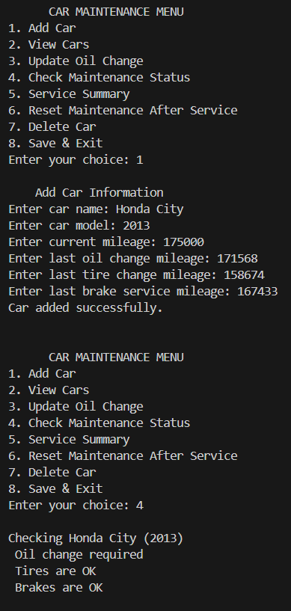
Output-2:

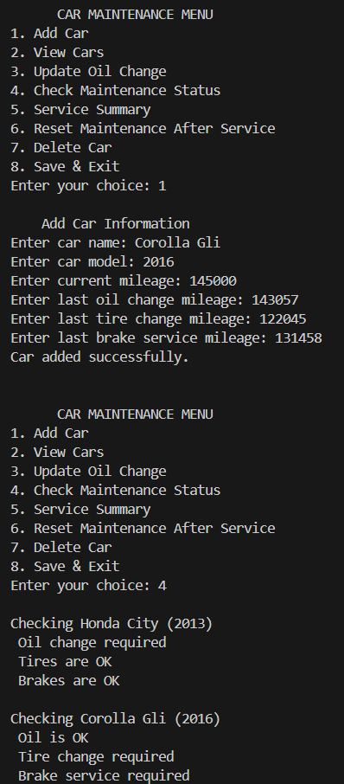
Output-3:

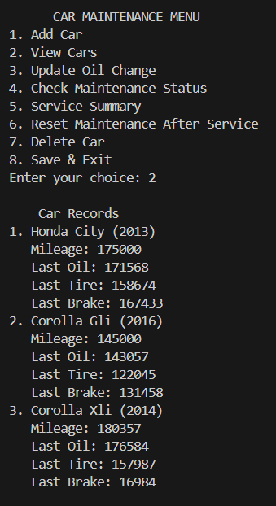
Output-4:

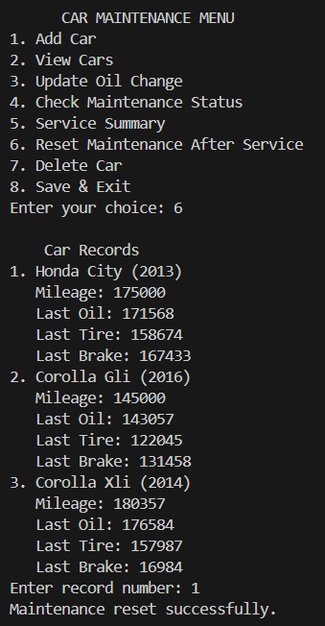
Output-5:

